# Infrared remote control vehicle

The reason why the vehicle can move is that the rotation of the motor shafts drive the wheels to rotate, and the motors rotate forward and backward to realize the forward and backward movement of the vehicle in all directions.

In this lesson, we will make a wireless infrared remote control vehicle.

## Install the infrared remote control vehicle

Completely disassemble the structure of the previous lesson

|  |  |
| --- | --- |
| SSJY2-01 套件 蹦蹦 赛车形态_空白视图 2 | SSJY2-01 套件 蹦蹦 赛车形态_空白视图 2_1 |
| SSJY2-01 套件 蹦蹦 赛车形态_空白视图 2_2 | SSJY2-01 套件 蹦蹦 赛车形态_空白视图 2_3 |
| SSJY2-01 套件 蹦蹦 赛车形态_空白视图 2_4 | SSJY2-01 套件 蹦蹦 赛车形态_空白视图 2_5 |
| SSJY2-01 套件 蹦蹦 赛车形态_空白视图 2_6 | SSJY2-01 套件 蹦蹦 赛车形态_空白视图 2_7 |
| SSJY2-01 套件 蹦蹦 赛车形态_空白视图 2_8 | SSJY2-01 套件 蹦蹦 赛车形态_空白视图 2_9 |
| SSJY2-01 套件 蹦蹦 赛车形态_空白视图 2_10 | SSJY2-01 套件 蹦蹦 赛车形态_空白视图 2_11 |
| SSJY2-01 套件 蹦蹦 赛车形态_空白视图 2_12 | SSJY2-01 套件 蹦蹦 赛车形态_空白视图 2_13 |
| SSJY2-01 套件 蹦蹦 赛车形态_空白视图 2_14 | SSJY2-01 套件 蹦蹦 赛车形态_空白视图 2_15 |
| SSJY2-01 套件 蹦蹦 赛车形态_空白视图 2_16 | SSJY2-01 套件 蹦蹦 赛车形态_空白视图 2_17 |
| SSJY2-01 套件 蹦蹦 赛车形态_空白视图 2_18 | SSJY2-01 套件 蹦蹦 赛车形态_空白视图 2_19 |
| SSJY2-01 套件 蹦蹦 赛车形态_空白视图 2_20 | SSJY2-01 套件 蹦蹦 赛车形态_空白视图 2_21 |
| SSJY2-01 套件 蹦蹦 赛车形态_空白视图 2_22 | SSJY2-01 套件 蹦蹦 赛车形态_空白视图 2_23 |
| SSJY2-01 套件 蹦蹦 赛车形态_空白视图 2_24 | SSJY2-01 套件 蹦蹦 赛车形态_空白视图 2_25 |
| SSJY2-01 套件 蹦蹦 赛车形态_空白视图 2_26 |  |
| Wiring diagram | |

## Drive motor

**Drive motor：**  
The motor driver chip used is TB6612, which is integrated into the expansion board. We have made some adjustments to its peripheral circuit. Four IO ports can control two motors well, instead of seven IO ports, which reduces the occupation of IO. You should know that when the work is large, the IO port of Arduino UNO is very valuable.

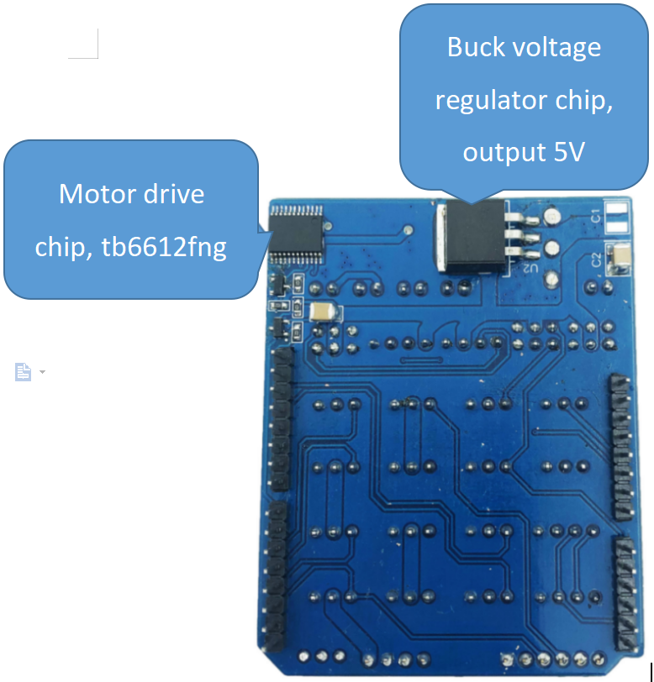

|  |  |
| --- | --- |
| Control pin of left motor | Control pin of right motor |
| The IO port to control direction: D7 | The IO port to control direction: D8 |
| The IO port to control speed: D6 | The IO port to control speed: D5 |

It is also very simple to control the direction of BENGBENG. The IO port of controlling direction outputs high level HIGH or low level LOW, and the speed IO port outputs analog value 0~255, which can control the forward or backward speed of the motor.

|  |  |  |  |  |
| --- | --- | --- | --- | --- |
| Left motor | | Right motor | | Direction |
| Direction IO level: HIGH | PWM value: 30~255 | Direction IO level: HIGH | PWM value: 30~255 | Forward |
| Direction IO level: LOW | PWM value: 30~255 | Direction IO level: LOW | PWM value: 30~255 | Backward |
| Direction IO level: LOW | PWM value: 30~255 | Direction IO level: HIGH | PWM value: 30~255 | Turn left |
| Direction IO level: HIGH | PWM value: 30~255 | Direction IO level: LOW | PWM value: 30~255 | Turn right |
| Direction IO level: LOW | PWM value: 30~255 | Direction IO level: LOW | PWM value: 30~255 | Stop |

1. **Example program**

|  |
| --- |
|  |

1. **Experiment phenomenon**

The vehicle moves forward for 2 seconds, moves backward for 2 seconds, turns left for 2 seconds, turns right for 2 seconds, and then stops.

### 3. Infrared remote control vehicle

In the previous few lessons, we learned to use the remote control and know the values of the buttons on it. Now we use it to control the vehicle movement.

The infrared remote control button value diagram is as follows:

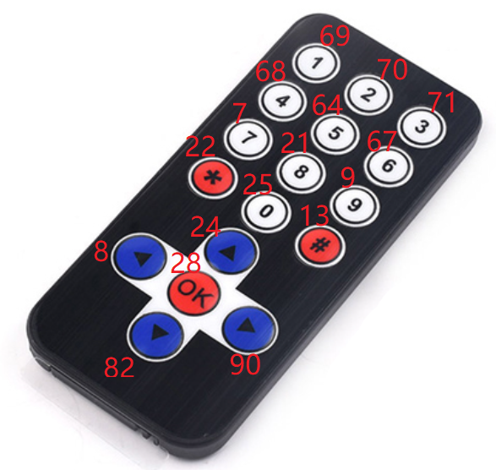

1. **Example program**

|  |
| --- |
|  |

1. **Experiment operation and phenomenon**

Click the direction button of the infrared remote control to control the movement direction of the vehicle, and click the OK button to stop it.